

***HTML Essentials***

**Lab Guides**

|  |  |
| --- | --- |
| Document Code | 25e-BM/HR/HDCV/FSOFT |
| Version | 1.1 |
| Effective Date | 20/11/2012 |

**Hanoi, 04/2019**

RECORD OF CHANGES

|  |  |  |  |  |  |
| --- | --- | --- | --- | --- | --- |
| No | Effective Date | Change Description | Reason | Reviewer | Approver |
|  | 25/Jun/2018 | Create a new Lab | Create new | DieuNT1 | VinhNV |
|  | 01/May/2019 | Update Fsoft Template | Update | DieuNT1 | VinhNV |
|  |  |  |  |  |  |
|  |  |  |  |  |  |
|  |  |  |  |  |  |
|  |  |  |  |  |  |
|  |  |  |  |  |  |
|  |  |  |  |  |  |
|  |  |  |  |  |  |
|  |  |  |  |  |  |

Contents

Unit 5 – Multimedia 4

Lab Objectives: 4

Problem Descriptions: 4

Guidelines: 5

Step 1: Analyze Requirements 5

Step 2: Build the table structure 5

Step 3: Add Table Header 6

Step 4: Add Table Row 6

Step 5: Add more data 7

Step 6: Group Cell in Table 8

Step 7: Group Rows in Table 9

Step 8: Add Caption and Highlight Column 10

Step 9: Verify the output 10

|  |  |
| --- | --- |
|  | **CODE: HTML-E.S.L401**  **TYPE: Short**  **LOC: N/A**  **DURATION: 30 MINUTES** |

# Unit 5 – Multimedia

## Lab Objectives:

* Understand HTML Table tags: <table>, <tbody>, <thead>, <tr>, <td>
* Able to create simple as well as complex table

## Problem Descriptions:

In this problem, we want to build a Timetable for a Fresher Front-end. The finished product look like figure below:

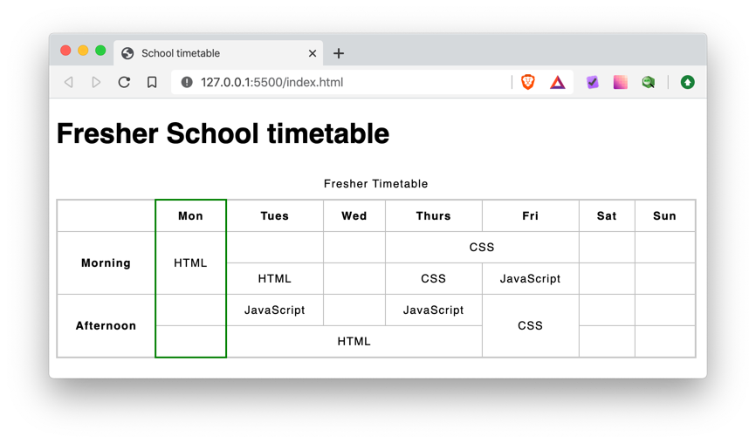

## Guidelines:

Step 1: Analyze Requirements

Firstly, we must analyze the output and identify as much elements as possible. By going from top to bottom, we check each block and have the result below:

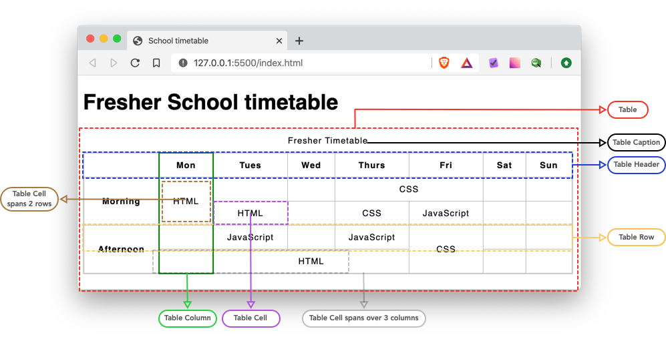

Step 2: Build the table structure

* We start with sample table structure like below:

1. <!DOCTYPE html>
2. <html>
3. <head>
4. <meta charset="utf-8" />
5. <title>School timetable</title>
6. <style>
7. html {
8. font-family: sans-serif;
9. }
10. table {
11. border-collapse: collapse;
12. border: 2px solid rgb(200, 200, 200);
13. letter-spacing: 1px;
14. font-size: 0.8rem;
15. }
16. td,
17. th {
18. border: 1px solid rgb(190, 190, 190);
19. padding: 10px 20px;
20. }
21. td {
22. text-align: center;
23. }
24. caption {
25. padding: 10px;
26. }
27. </style>
28. </head>
29. <body>
30. <h1>Fresher School timetable</h1>
31. <table>
32. <thead>
33. </thead>
34. <tbody>
35. </tbody>
36. </table>
37. </body>
38. </html>

Note: we only add the structure. There is no content so if you won’t see the table yet.

Step 3: Add Table Header

Next, we add Table Header which is 7 day of the Week: Monday until Sunday. Add more code to <thead> tag:

1. <thead>
2. <tr>
3. <th scope="col">Mon</th>
4. <th scope="col">Tues</th>
5. <th scope="col">Wed</th>
6. <th scope="col">Thurs</th>
7. <th scope="col">Fri</th>
8. <th scope="col">Sat</th>
9. <th scope="col">Sun</th>
10. </tr>
11. </thead>

You should get similar output like figure below:

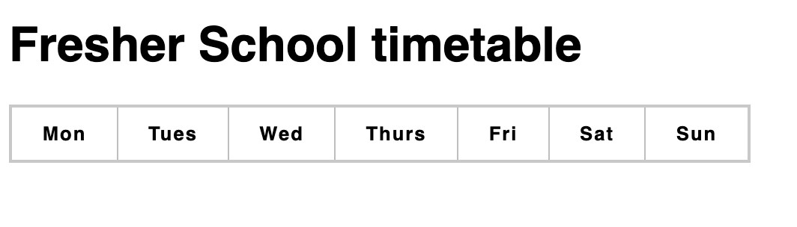

Step 4: Add Table Row

Next we need to add Table row (each row represents the timetable of a Front-end Fresher):

1. <tbody>
2. <tr>
3. <td>HTML</td>
4. <td>&nbsp;</td>
5. <td>&nbsp;</td>
6. <td>CSS</td>
7. <td>CSS</td>
8. <td>&nbsp;</td>
9. <td>&nbsp;</td>
10. </tr>
11. </tbody>

You should see that the student has HTML on Monday and CSS class on Thursday and Friday.

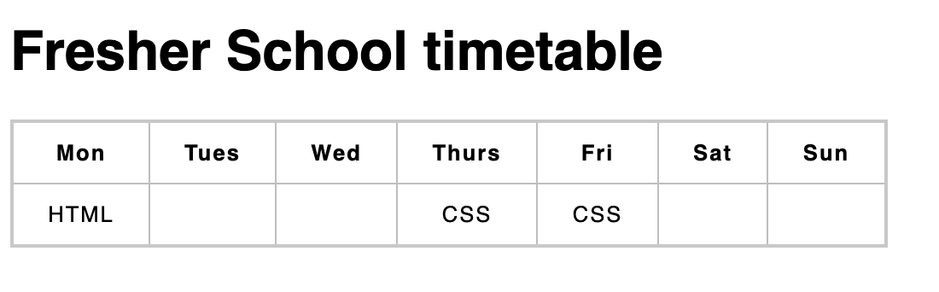

Step 5: Add more data

We continue adding more row into the table:

1. <tbody>
2. <tr>
3. <td>HTML</td>
4. <td>&nbsp;</td>
5. <td>&nbsp;</td>
6. <td>CSS</td>
7. <td>CSS</td>
8. <td>&nbsp;</td>
9. <td>&nbsp;</td>
10. </tr>
11. <tr>
12. <td>HTML</td>
13. <td>HTML</td>
14. <td>&nbsp;</td>
15. <td>CSS</td>
16. <td>JavaScript</td>
17. <td>&nbsp;</td>
18. <td>&nbsp;</td>
19. </tr>
20. <tr>
21. <td>&nbsp;</td>
22. <td>JavaScript</td>
23. <td>&nbsp;</td>
24. <td>JavaScript</td>
25. <td>CSS</td>
26. <td>&nbsp;</td>
27. <td>&nbsp;</td>
28. </tr>
29. <tr>
30. <td>&nbsp;</td>
31. <td>HTML</td>
32. <td>HTML</td>
33. <td>HTML</td>
34. <td>CSS</td>
35. <td>&nbsp;</td>
36. <td>&nbsp;</td>
37. </tr>
38. </tbody>

We have now a full schedule of Front-end Fresher:

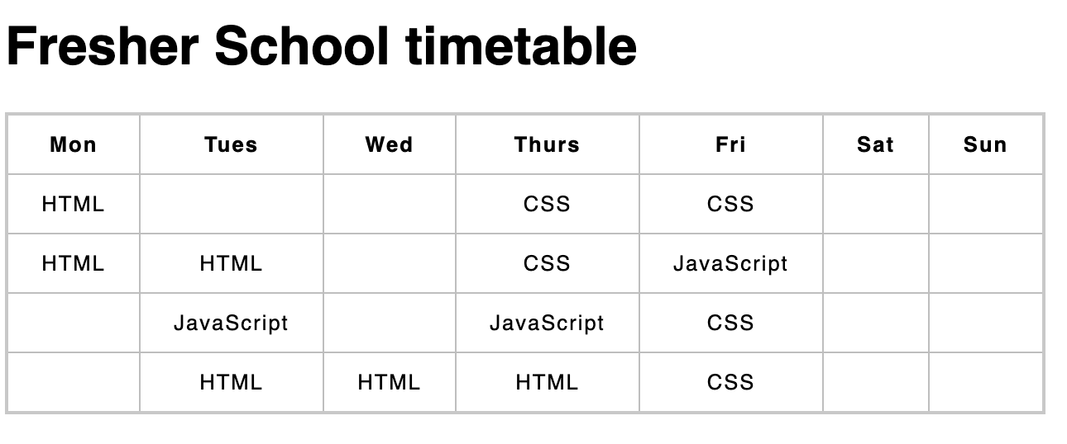

Step 6: Group Cell in Table

* We can group same value in the table together with attribute colspan and rowspan.
* Let’s group HTML on Monday, by adding rowspan=”2” to the <td> tag of first <tr>. Also, we needs to remove the <td> tag in second <tr> else the seconds row will have more data.

1. <tr>
2. <td rowspan="2">HTML</td>
3. <td>&nbsp;</td>
4. <td>&nbsp;</td>
5. <td>CSS</td>
6. <td>CSS</td>
7. <td>&nbsp;</td>
8. <td>&nbsp;</td>
9. </tr>
10. <tr>
11. <td>HTML</td>
12. <td>&nbsp;</td>
13. <td>CSS</td>
14. <td>JavaScript</td>
15. <td>&nbsp;</td>
16. <td>&nbsp;</td>
17. </tr>

* Next, we group CSS class on Thursday and Friday together. But this time, we have to use colspan attribute. Add colspan=”2” to the 4th <td> tag (Line 5 in above code) and remove the line 6:

1. <tr>
2. <td rowspan="2">HTML</td>
3. <td>&nbsp;</td>
4. <td>&nbsp;</td>
5. <td colspan="2">CSS</td>
6. <td>&nbsp;</td>
7. <td>&nbsp;</td>
8. </tr>

* Next, we group HTML on 4th row (Tuesday to Thursday) and CSS (on Friday)
* See the code below:

1. <tbody>
2. <tr>
3. <td rowspan="2">HTML</td>
4. <td>&nbsp;</td>
5. <td>&nbsp;</td>
6. <td colspan="2">CSS</td>
7. <td>&nbsp;</td>
8. <td>&nbsp;</td>
9. </tr>
10. <tr>
11. <td>HTML</td>
12. <td>&nbsp;</td>
13. <td>CSS</td>
14. <td>JavaScript</td>
15. <td>&nbsp;</td>
16. <td>&nbsp;</td>
17. </tr>
18. <tr>
19. <td>&nbsp;</td>
20. <td>JavaScript</td>
21. <td>&nbsp;</td>
22. <td>JavaScript</td>
23. <td rowspan="2">CSS</td>
24. <td>&nbsp;</td>
25. <td>&nbsp;</td>
26. </tr>
27. <tr>
28. <td>&nbsp;</td>
29. <td colspan="3">HTML</td>
30. <td>&nbsp;</td>
31. <td>&nbsp;</td>
32. </tr>
33. </tbody>

Step 7: Group Rows in Table

Suppose we want to group 1st with 2nd row into Morning class and 3rd row with 4th row into Afternoon class. We can implements that with <th>:

1. <table>
2. <thead>
3. <tr>
4. <td></td> <!-- Add empty cell -->
5. <th scope="col">Mon</th>
6. <th scope="col">Tues</th>
7. <th scope="col">Wed</th>
8. <th scope="col">Thurs</th>
9. <th scope="col">Fri</th>
10. <th scope="col">Sat</th>
11. <th scope="col">Sun</th>
12. </tr>
13. </thead>
14. <tbody>
15. <tr>
16. <th rowspan="2">Morning</th> <!-- Add heading -->
17. <td rowspan="2">HTML</td>
18. <td>&nbsp;</td>
19. <td>&nbsp;</td>
20. <td colspan="2">CSS</td>
21. <td>&nbsp;</td>
22. <td>&nbsp;</td>
23. </tr>
24. <tr>
25. <td>HTML</td>
26. <td>&nbsp;</td>
27. <td>CSS</td>
28. <td>JavaScript</td>
29. <td>&nbsp;</td>
30. <td>&nbsp;</td>
31. </tr>
32. <tr>
33. <th rowspan="2">Afternoon</th> <!-- Add heading -->
34. <td>&nbsp;</td>
35. <td>JavaScript</td>
36. <td>&nbsp;</td>
37. <td>JavaScript</td>
38. <td rowspan="2">CSS</td>
39. <td>&nbsp;</td>
40. <td>&nbsp;</td>
41. </tr>
42. <tr>
43. <td>&nbsp;</td>
44. <td colspan="3">HTML</td>
45. <td>&nbsp;</td>
46. <td>&nbsp;</td>
47. </tr>
48. </tbody>
49. </table>

Step 8: Add Caption and Highlight Column

Lastly, we add caption to the table with <caption> tag inside <table> tag to give the table more meaningful information. And we highlight the Monday row to mark it as the start of the week with <colgroup> tag:

1. <!-- Add caption -->
2. <caption>
3. Fresher Timetable
4. </caption>
5. <!-- Highlight Monday column -->
6. <colgroup>
7. <col span="1" />
8. <col style="border: 2px solid green;" />
9. </colgroup

Step 9: Verify the output

If you are doing correctly, you should have a Timetable like figure in Problem Description.

Refer to the source code below if you are stuck:

1. <!DOCTYPE html>
2. <html>
3. <head>
4. <meta charset="utf-8" />
5. <title>School timetable</title>
6. <style>
7. html {
8. font-family: sans-serif;
9. }
10. table {
11. border-collapse: collapse;
12. border: 2px solid rgb(200, 200, 200);
13. letter-spacing: 1px;
14. font-size: 0.8rem;
15. }
16. td,
17. th {
18. border: 1px solid rgb(190, 190, 190);
19. padding: 10px 20px;
20. }
21. td {
22. text-align: center;
23. }
24. caption {
25. padding: 10px;
26. }
27. </style>
28. </head>
29. <body>
30. <h1>Fresher School timetable</h1>
31. <table>
32. <!-- Add caption -->
33. <caption>
34. Fresher Timetable
35. </caption>
36. <!-- Highlight Monday column -->
37. <colgroup>
38. <col span="1" />
39. <col style="border: 2px solid green;" />
40. </colgroup>
41. <thead>
42. <tr>
43. <td></td> <!-- Add empty cell -->
44. <th scope="col">Mon</th>
45. <th scope="col">Tues</th>
46. <th scope="col">Wed</th>
47. <th scope="col">Thurs</th>
48. <th scope="col">Fri</th>
49. <th scope="col">Sat</th>
50. <th scope="col">Sun</th>
51. </tr>
52. </thead>
53. <tbody>
54. <tr>
55. <th rowspan="2">Morning</th> <!-- Add heading -->
56. <td rowspan="2">HTML</td>
57. <td>&nbsp;</td>
58. <td>&nbsp;</td>
59. <td colspan="2">CSS</td>
60. <td>&nbsp;</td>
61. <td>&nbsp;</td>
62. </tr>
63. <tr>
64. <td>HTML</td>
65. <td>&nbsp;</td>
66. <td>CSS</td>
67. <td>JavaScript</td>
68. <td>&nbsp;</td>
69. <td>&nbsp;</td>
70. </tr>
71. <tr>
72. <th rowspan="2">Afternoon</th> <!-- Add heading -->
73. <td>&nbsp;</td>
74. <td>JavaScript</td>
75. <td>&nbsp;</td>
76. <td>JavaScript</td>
77. <td rowspan="2">CSS</td>
78. <td>&nbsp;</td>
79. <td>&nbsp;</td>
80. </tr>
81. <tr>
82. <td>&nbsp;</td>
83. <td colspan="3">HTML</td>
84. <td>&nbsp;</td>
85. <td>&nbsp;</td>
86. </tr>
87. </tbody>
88. </table>
89. </body>
90. </html>

**-- THE END --**